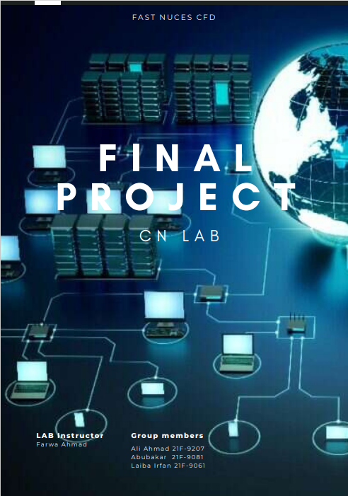

|  |  |  |
| --- | --- | --- |
|  | National University  of Computer and Emerging Sciences  Chiniot-Faisalabad Campus |  |

**COMPUTER NETWORKS LAB**

**FALL 2023**

***Submitted by***

|  |  |
| --- | --- |
| ***Ali Ahmad*** | ***21F-9207*** |
| ***Abubakar*** | ***21F-9081*** |
| ***Laiba Irfan*** | ***21F-9061*** |

**Submitted To**

“**FARWA AHMAD**”

**Topology:**

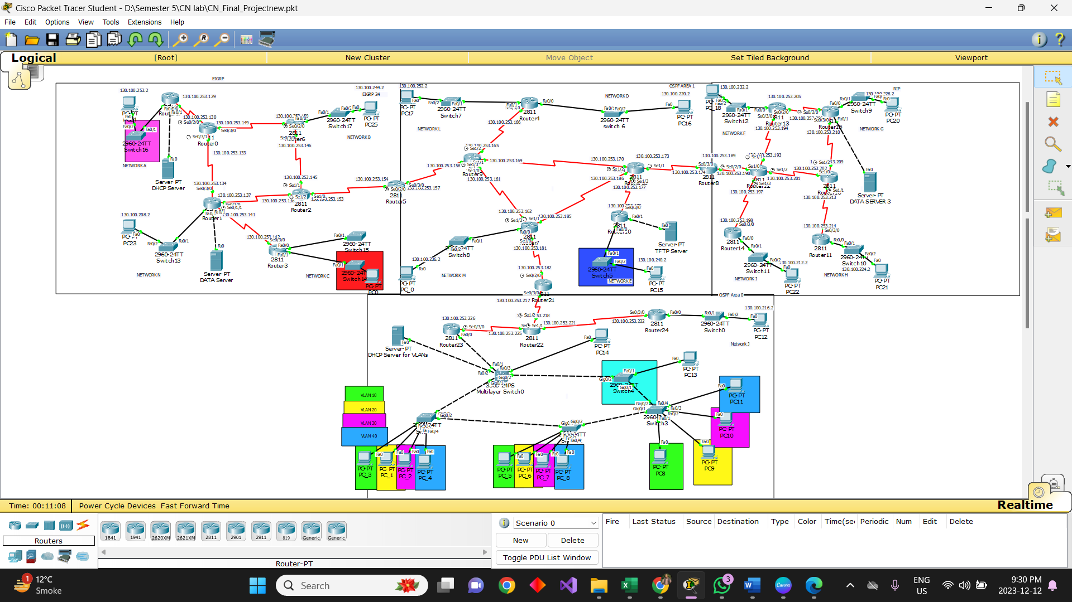

**ERGP (Block 1):**

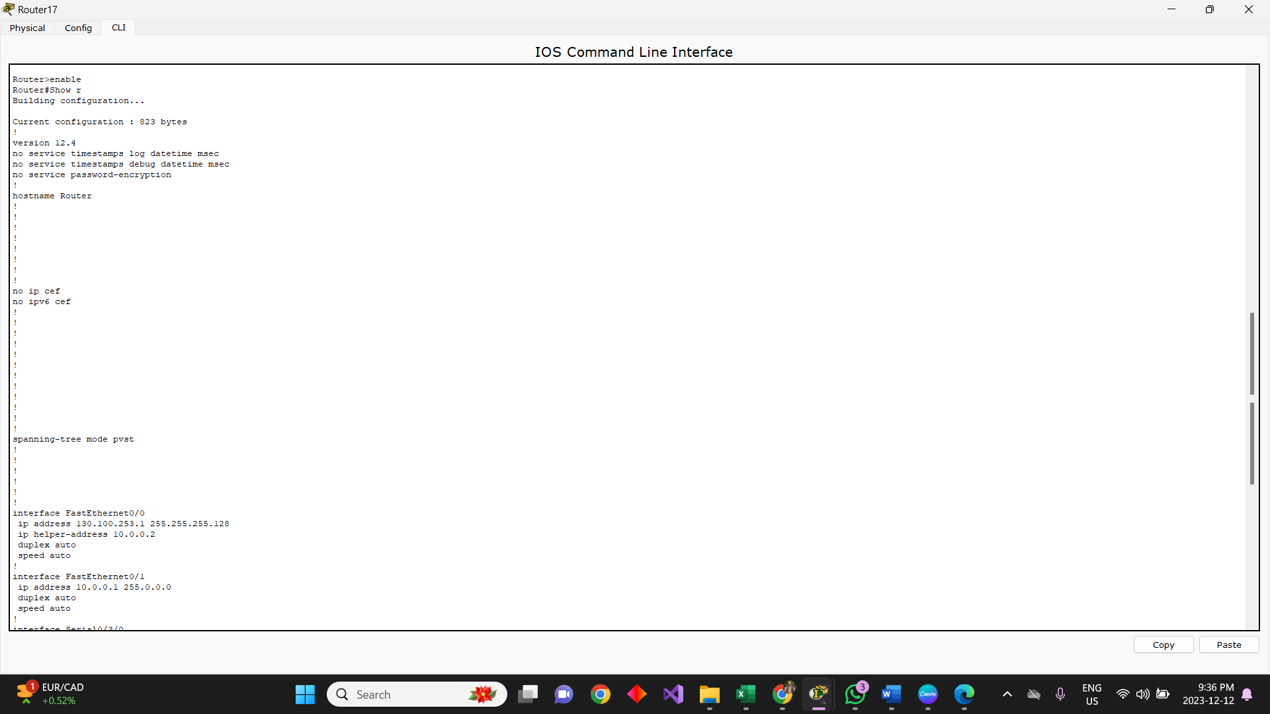

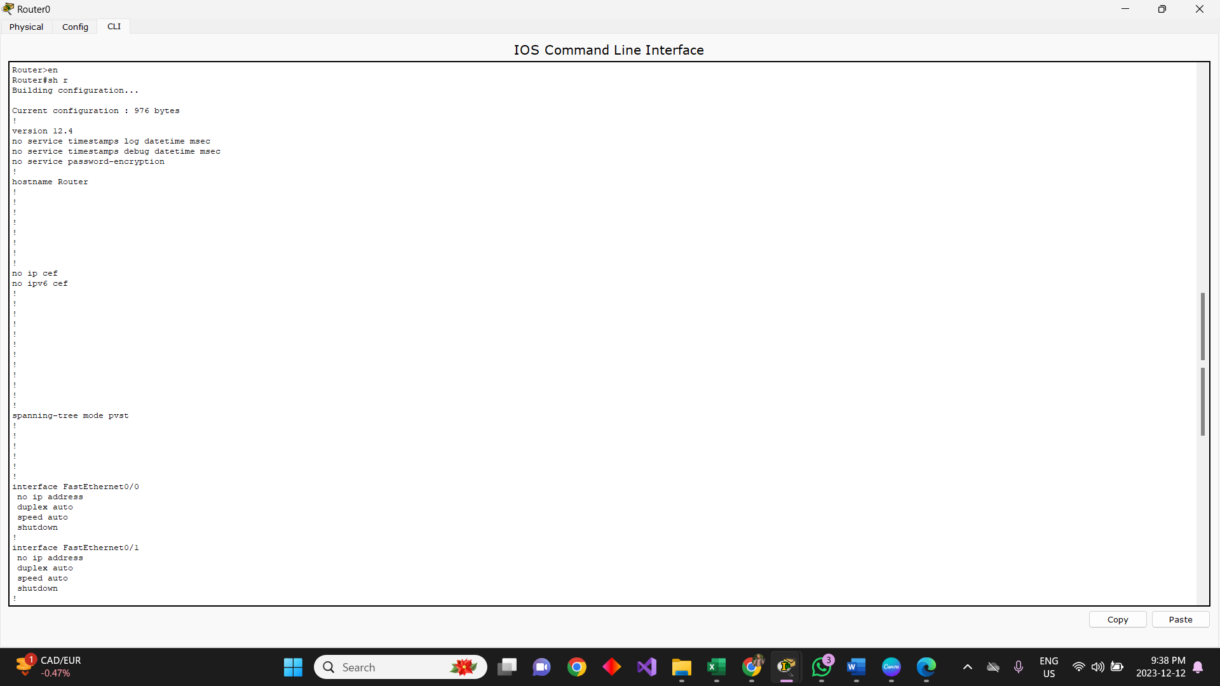

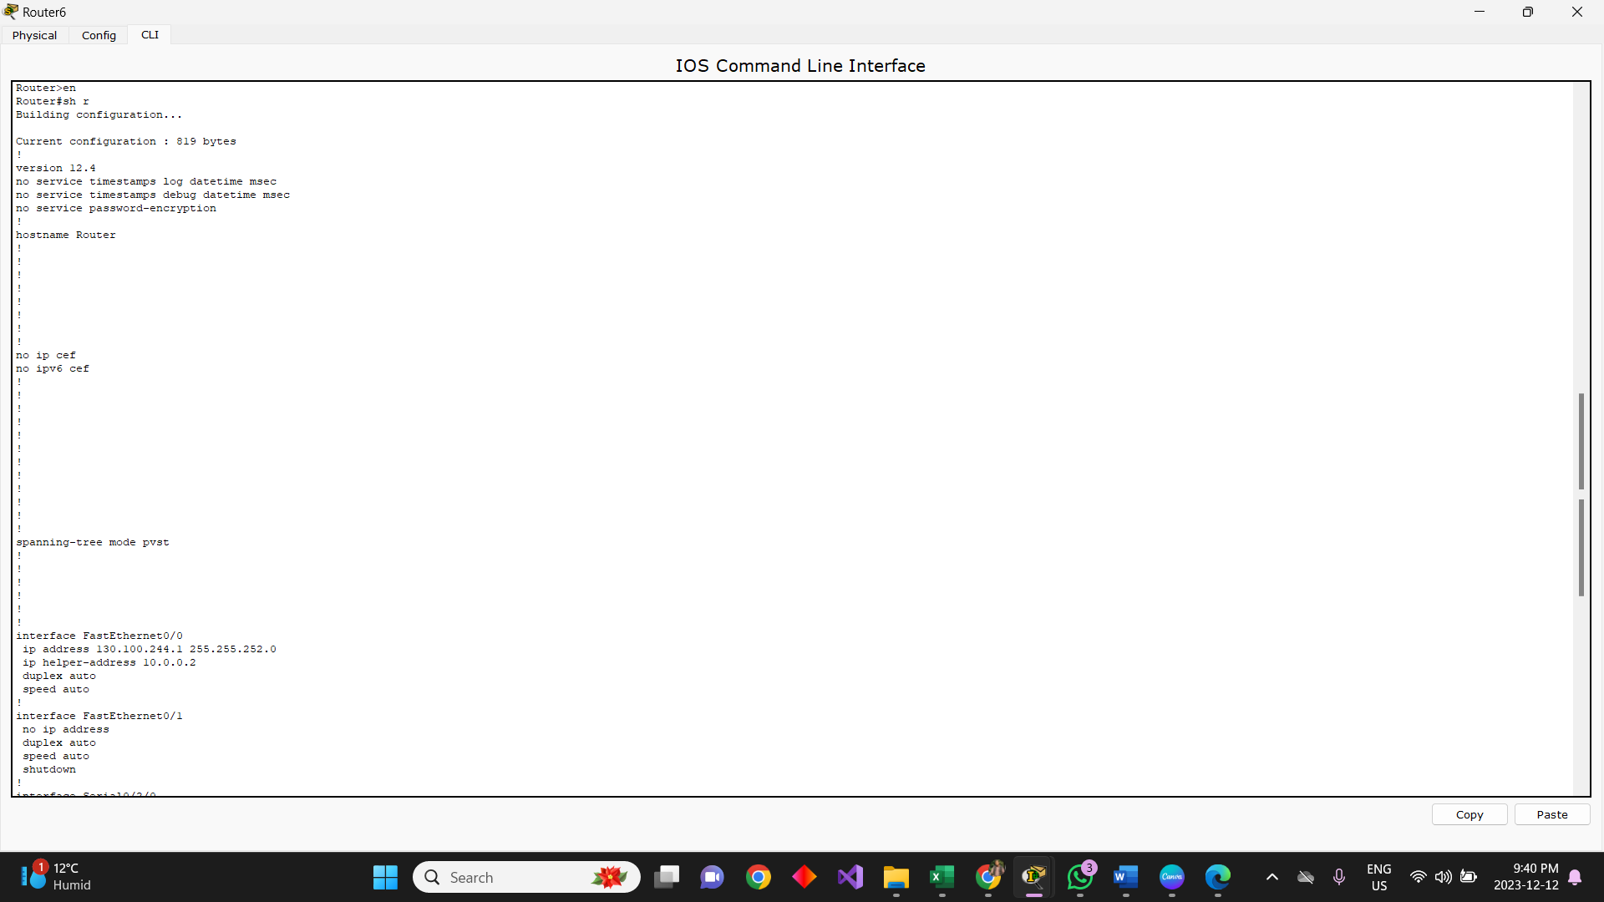

**Router 5 (EIGRP – OSPF):**

**Redistribution:**

**OSPF (Block 2) (Area 1):**

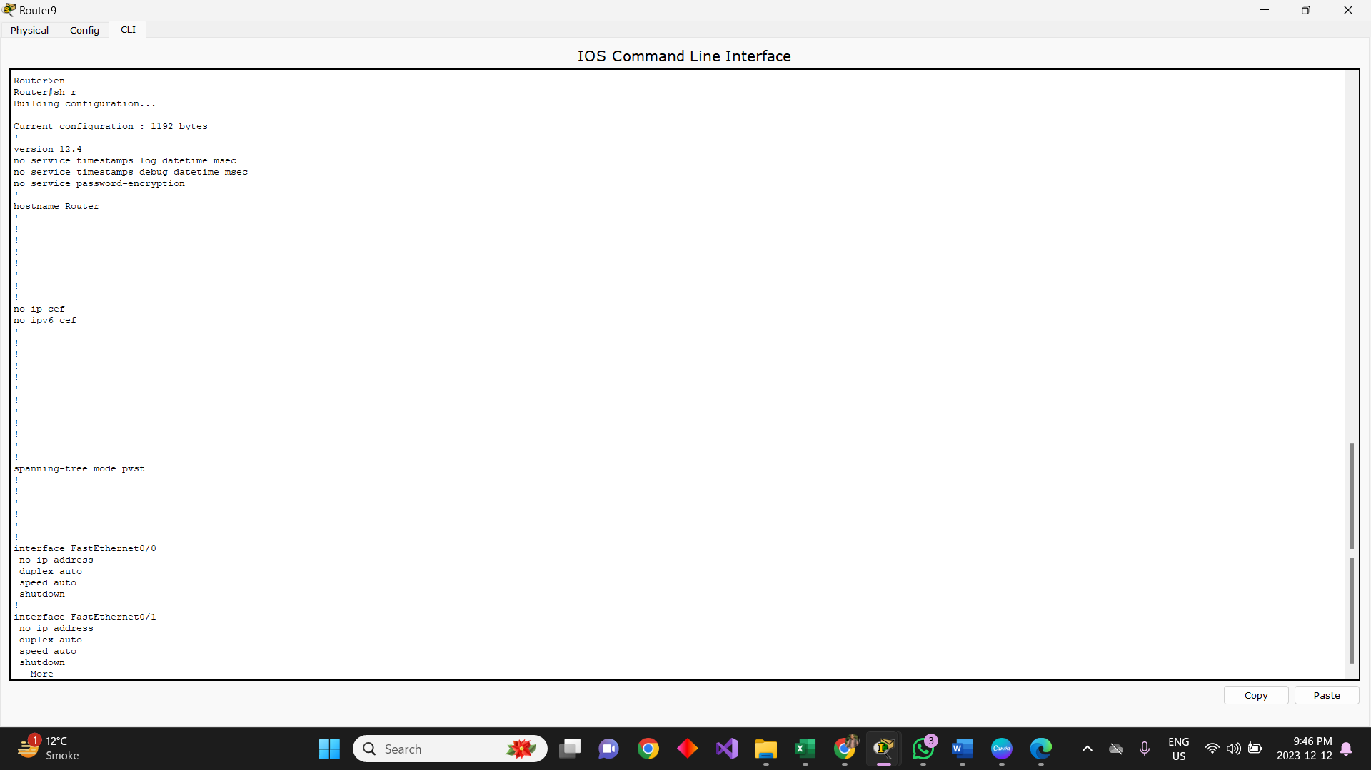

**Router 8 (OSPF – RIP):**

**Redistribution:**

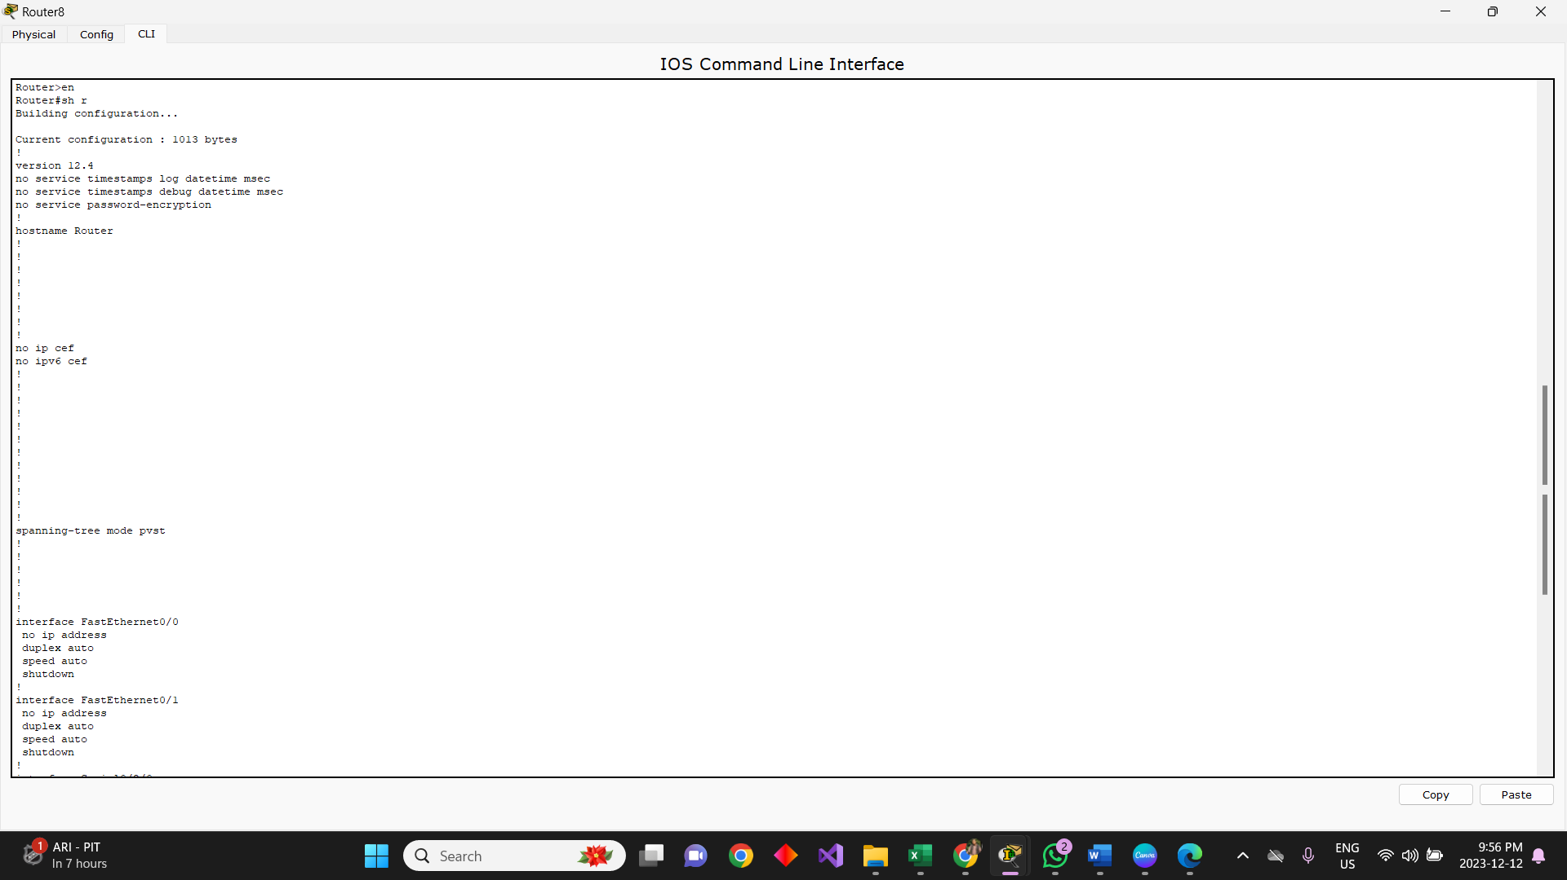

**RIP (Block 3):**

**Router 21 (OSPF – OSPF):**

**OSPF (Block 4)(Area 0):**

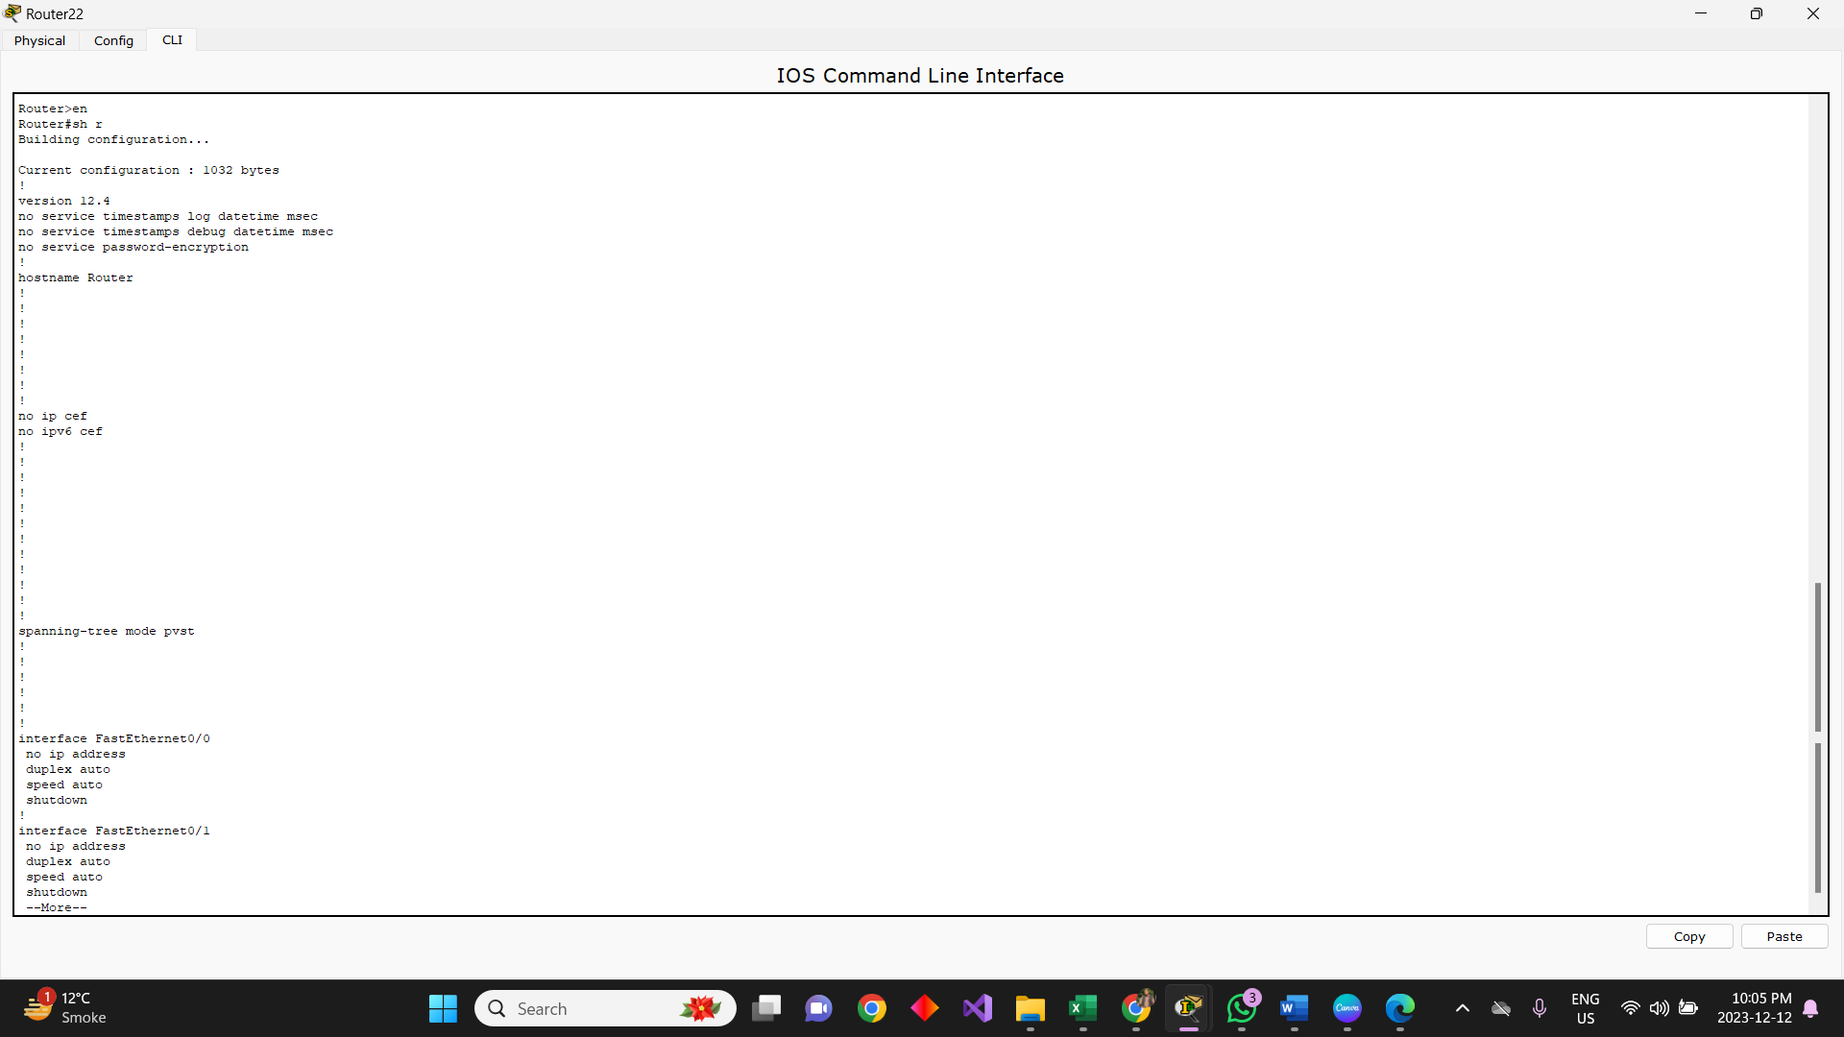

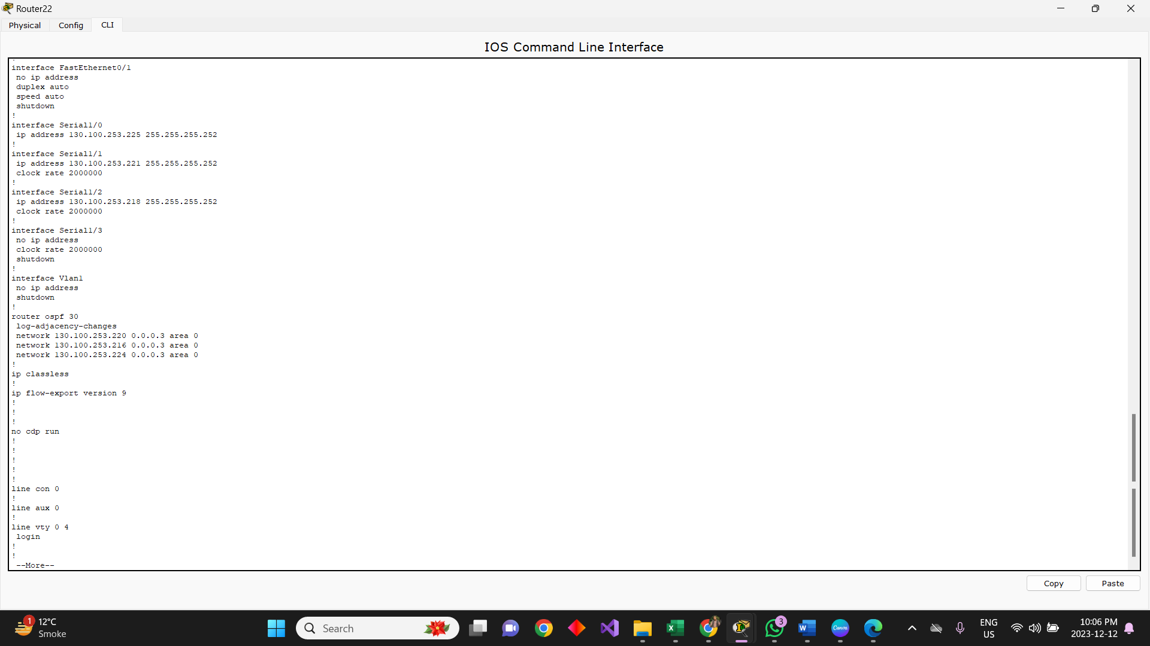

**Multi-layer Switch:**

**DHCP-Server (Block 1):**

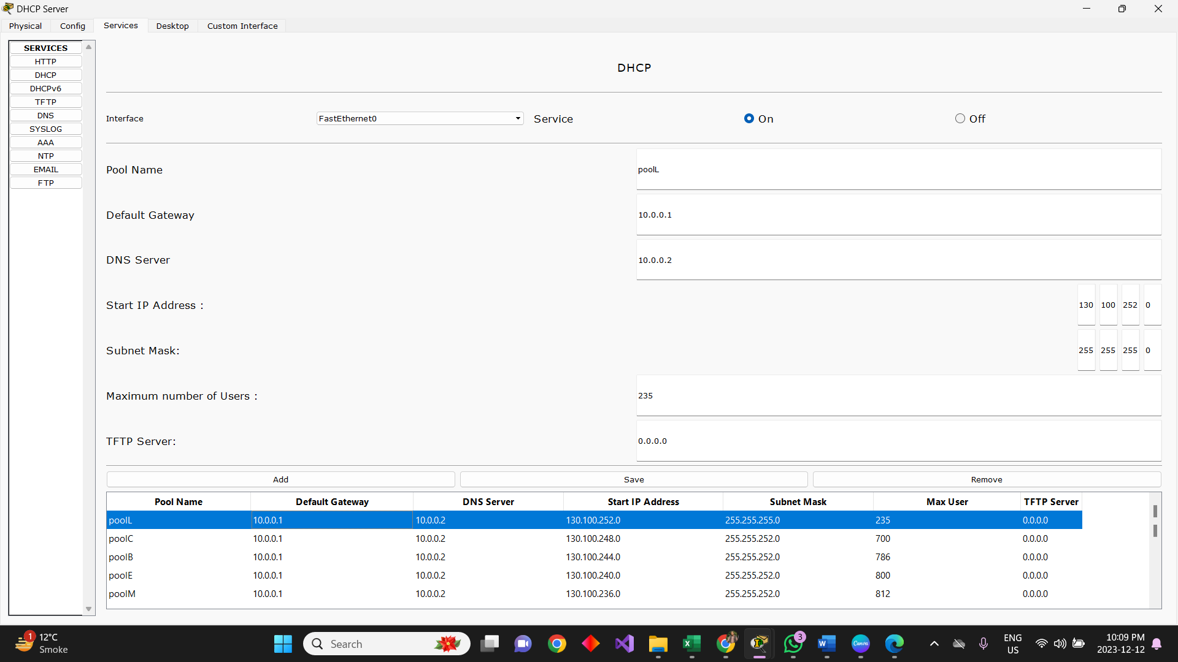

**DHCP-Server for Vlan (Block 4):**

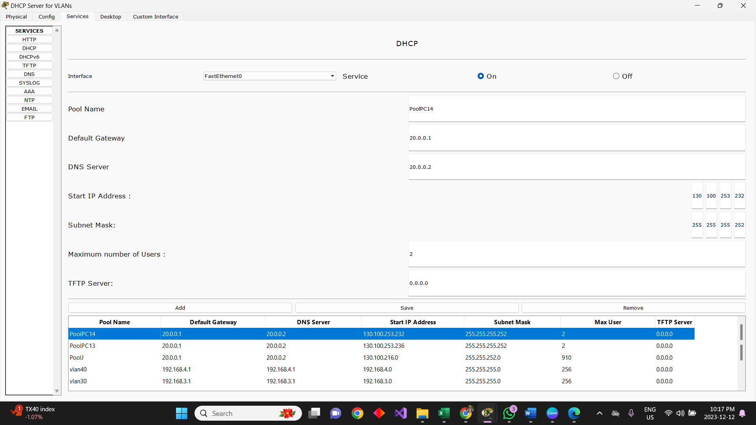

**Communication:**

**EIGRP:**

**OSPF (Block 2):**

**RIP (Block 3):**

**OSPF (Block 4):**

**EIGRP – OSPF (Block 1 - 2):**

**OSPF – RIP (Block 2 - 3):**

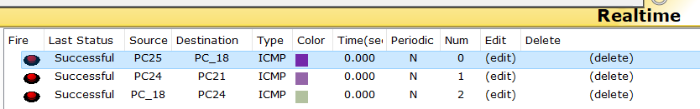

**OSPF - OSPF (Block 2 - 4):**

**Vlans:**

(Only Vlan 20 and 40 communicates with each other)

**Restriction from network C (Red switch) to Vlan 40:**

**Restriction from Data-server3 to Network A(Pink switch):**

**Restriction from TFTP-server to Network M:**

**Restriction from data-server to Network L:**

